Emergency Blowdown Ring Drive
White Paper Proof of Concept for Pressure-Based Survival Thrust Inside a Stabilized PTEC Ring Architecture
Document Type | Emergency propulsion proof-of-concept white paper
Concept Thesis | Use a PTEC ring to create a loaded motion or pressure state, a maglev shell to keep the ring centered and stable, and a pressure system as an emergency reaction-thrust path when the normal output stage fails.
Primary Use | Emergency thrust, drift correction, attitude trim, separation, and post-failure maneuver control
Status | High-level survival-drive architecture draft
Abstract
Emergency Blowdown Ring Drive is a survival-mode propulsion concept built around three linked roles: a ring of spinning PTECs that establishes the loaded motion or pressure state, a surrounding maglev-derived shell that centers and damps the assembly, and a pressure reservoir or blowdown path that provides the actual emergency reaction thrust when the normal output stage is lost. The point of the concept is not to replace the primary drive. The point is to preserve a usable reaction path after major failure so the craft can still trim attitude, reduce drift, separate safely, or maintain minimum control authority. In this framing, the ring creates the state, the maglev shell keeps that state usable, and the pressure system becomes the last honest thrust source when everything else has gone quiet.
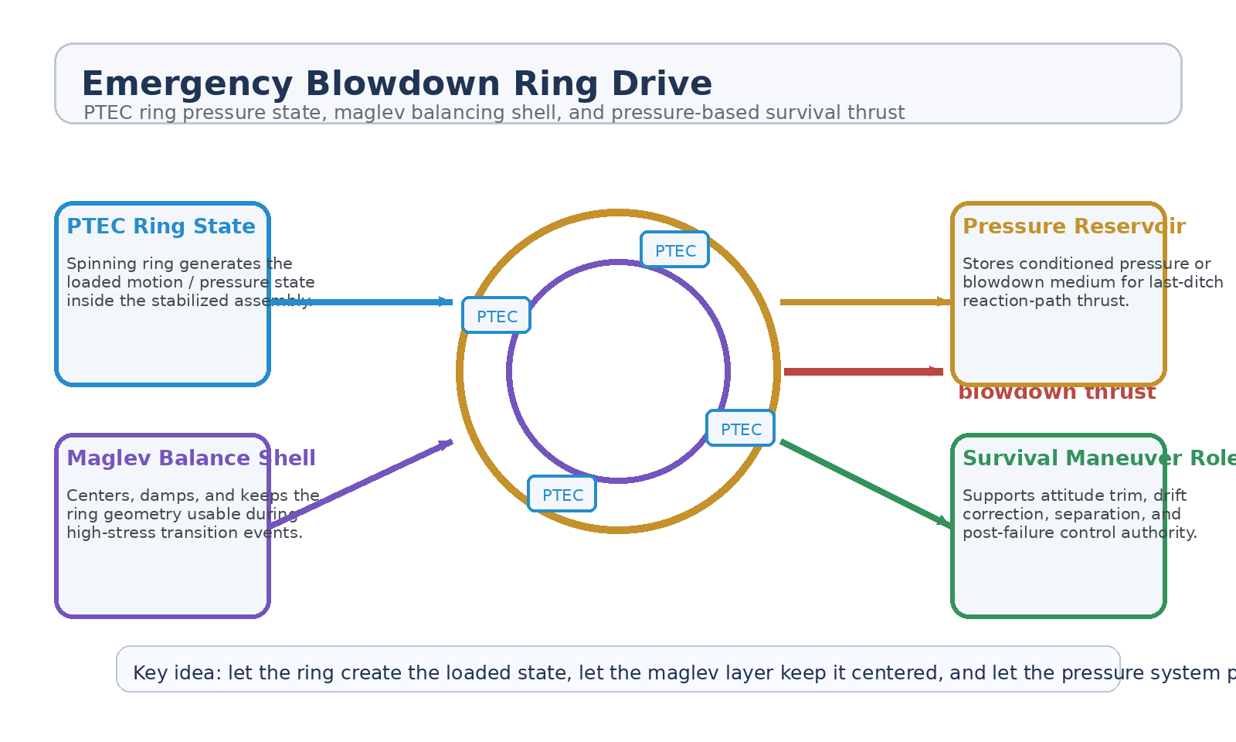
Figure 1. Emergency Blowdown Ring Drive with PTEC ring state, maglev balancing shell, pressure reservoir, and blowdown thrust path.
1. Concept Thesis
The central claim is modest and coherent: if a stabilized ring architecture already contains a loaded motion or pressure state, then a stored-pressure or blowdown system can be repurposed as a survival-thrust path when the normal output stage fails. This is more believable than claiming that the maglev shell itself suddenly becomes the main propulsion system. The shell remains a control and balancing layer. The pressure system supplies the emergency reaction path.
That makes the architecture stronger because each subsystem keeps a clear job under failure.
2. Why the Combined Concepts Fit
The earlier maglev stabilization paper already defines the maglev layer as centering, damping, and transition control rather than as primary propulsion. That same role is exactly what a loaded ring assembly needs during a blowdown event: the pressure release is useful only if the system remains aligned and does not tear itself loose under the transient.
The docking-coupling logic reinforces the same doctrine. Maglev behaves best as the field layer that makes a stressful event graceful: capture before impact there, and stability before emergency thrust here.
3. System Architecture
Layer | Subsystem | Primary Function | Emergency Role
L1 | PTEC Ring | Generate the loaded motion / field / pressure state within the ring architecture. | Stored energetic state
L2 | Maglev Balance Shell | Center, damp, and stabilize the ring under transient stress. | Keeps blowdown usable
L3 | Pressure Reservoir | Maintain a reserved medium or conditioned pressure source for emergency release. | Survival thrust source
L4 | Blowdown Path / Nozzle | Convert reservoir release into an actual reaction-thrust event. | Emergency reaction path
L5 | Survival Control Bus | Spend scarce thrust on the minimum maneuvers that preserve the craft. | Post-failure control authority

3.1 PTEC Ring State
The ring should be understood as the state generator. Its role is to produce the loaded internal condition that the rest of the system tries to preserve and use. In ordinary operation, that state would be handed to the normal output stage. In emergency mode, the architecture falls back to a pressure-driven path instead.
3.2 Maglev Shell as Survival Stabilizer
The maglev layer does not suddenly become the main drive. It keeps the ring centered, suppresses transient wobble, and maintains alignment during the pressure event. That interpretation is consistent with its strongest use elsewhere: disciplined capture, trim, and damping rather than miracle thrust.
3.3 Blowdown as the Honest Thrust Source
The most believable propulsion claim in this emergency scenario is stored-pressure blowdown. That gives the craft a real reaction path instead of pretending internal field motion alone generates net thrust. The output may be limited, but it is honest, directional, and useful when survival matters more than performance.
4. Most Credible Emergency Uses
• Attitude trim after partial drive failure.
• Drift correction to avoid uncontrolled tumble or trajectory loss.
• Controlled separation from a dock, debris field, or failing structure.
• Short emergency vector change to protect life support or communications posture.
• Minimum safe maneuver authority during a degraded return or rescue window.
5. Why This Is Stronger Than Treating Maglev as the Drive
• Keeps the maglev layer in its strongest and most believable role: stability and control.
• Uses a real pressure-based reaction path for net thrust.
• Preserves the ring architecture as the state generator rather than forcing it to explain everything.
• Creates a cleaner separation between ordinary output mode and failure fallback mode.
• Turns a pressure system into a survival tool rather than dead mass held in reserve.
6. Boundaries and Realism
Emergency Blowdown Ring Drive should be framed honestly as a survival-thrust architecture. It is not a full-duration propulsion system, not a replacement for the main output stage, and not proof that the maglev shell propels the ship in free space. Its value is in buying control authority during failure. The pressure event is short, finite, and precious. The maglev shell makes it cleaner. The ring makes it more coherent. But the system remains fundamentally a limited emergency tool.
• Most credible as a last-ditch or degraded-mode thrust path.
• Not a replacement for the primary propulsion stack.
• Limited by stored pressure mass, nozzle geometry, and event duration.
• Best used for survival maneuvers, not routine cruise or combat thrust.
7. Operating Modes
Mode | Ring Behavior | Pressure Behavior | Outcome
Standby Reserve | Ring remains stabilized and ready. | Reservoir stays isolated and preserved. | Emergency option retained
Failure Capture | Maglev shell arrests wobble after normal output loss. | Pressure path is armed but not spent. | Craft regains posture
Blowdown Pulse | Ring remains centered during short release. | Stored pressure is expended into reaction thrust. | Immediate control authority
Recovery Drift | Ring and shell settle into low-disturbance state. | Remaining pressure is rationed for minimum corrections. | Longer survival window

8. Proof-of-Concept Build Path
Phase | Goal | Bench / Program Activity | Success Signal
P1 | Ring baseline | Characterize the stabilized ring state under maglev balancing without blowdown activation. | Stable centered assembly
P2 | Transient control | Introduce controlled disturbance and measure maglev damping performance. | Reduced wobble
P3 | Pressure-path integration | Add a surrogate pressure reservoir and reaction path to the stabilized ring mockup. | Usable emergency path
P4 | Blowdown pulse test | Observe whether the ring remains aligned during a short reaction-thrust event. | Cleaner emergency release
P5 | Failure-mode comparison | Compare no-reserve and blowdown-reserve cases in a degraded-output scenario. | Clear survival-control advantage

9. Conclusion
Emergency Blowdown Ring Drive is strongest when treated as a graceful failure architecture. The PTEC ring creates the loaded state. The maglev shell keeps that state disciplined. The pressure system provides the actual last-ditch thrust. The result is not a new primary engine. It is a better answer to the question of what still moves the craft after the normal output path dies.
As a white paper PoC, it is best understood as the emergency reaction layer inside a stabilized ring architecture: finite, honest, and worth having when survival depends on one more controlled push.
Working one-line doctrine: Let the ring create the loaded state, let the maglev layer keep it centered, and let the pressure system provide the emergency reaction-thrust path when normal output stages fail.

